For Creating Lambda Function in AWS

Step 1:

Login to AWS portal.

Step2:

Click on **services** inAWS console.

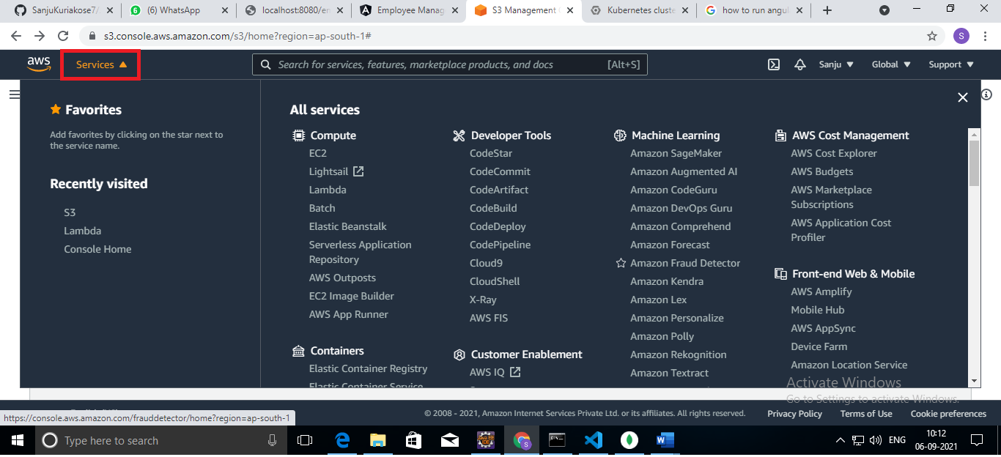

Step 3 :

Click on **Lambda** in services.

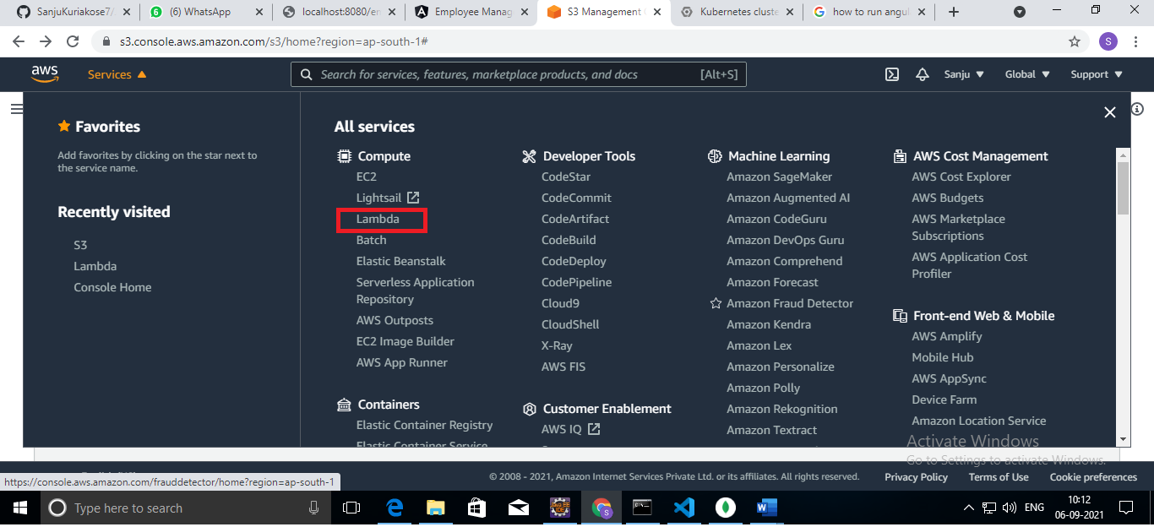

Step 4:

Open the Function page on the Lambda console and click on the Create function.

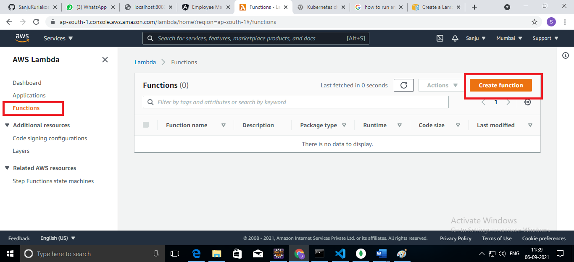

Step 5:

Choose the ‘Author from scratch’ option to create function.

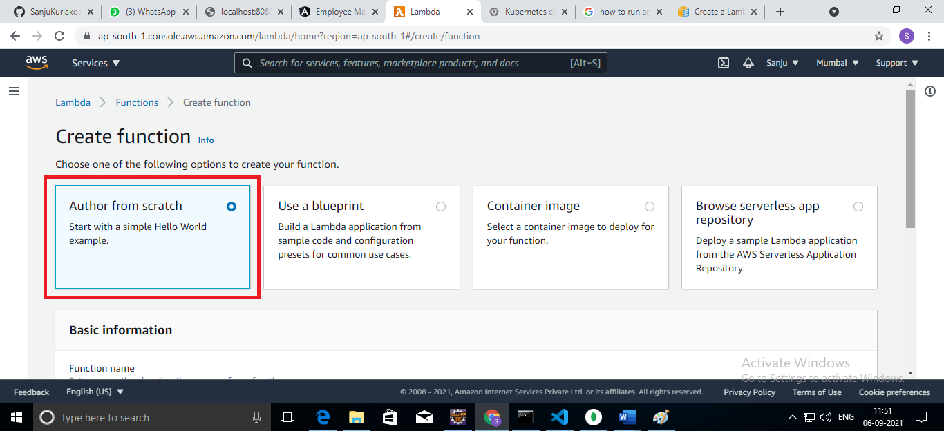

Step 6:

Fill the all mandatory information under Basic Information.

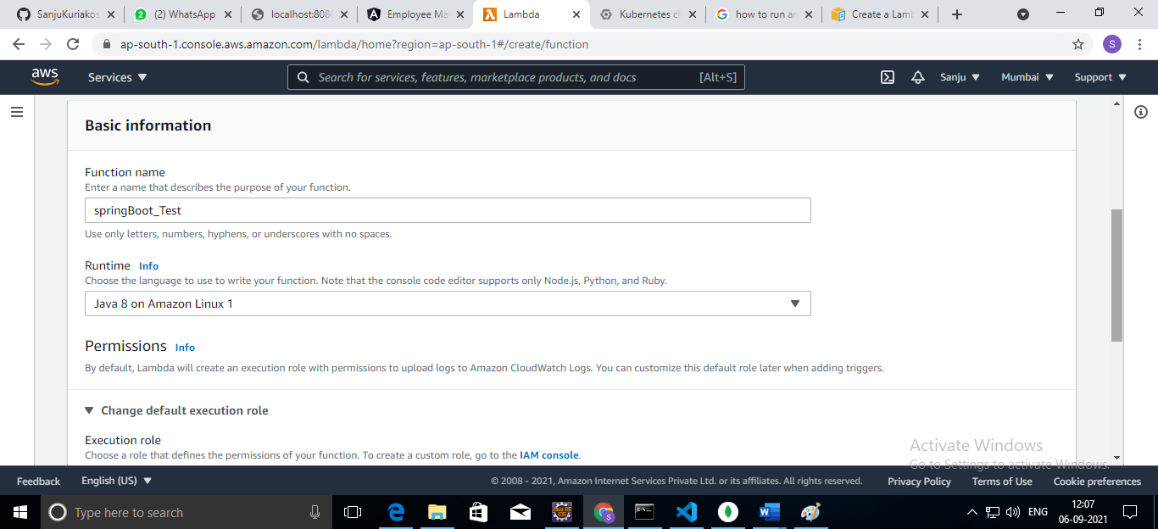

Step 7:

Click on the Create function.

